08.02.2016.

On November 13, 2015 the Ministry of Justice of the Republic of Latvia, the Central Financing and Contracting Department of the Ministry of Finance and the Delegation of European Union to the Beneficiary Country signed an agreement on implementation of the Twinning Project Strengthening the Rule of Law, MK 11 IB JH 03 (hereinafter – the Project).
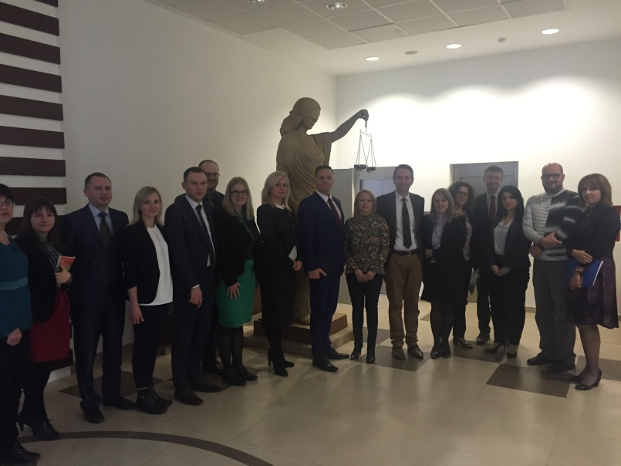
On November 16 and 17, 2015 in Skopje several working visits took place with participation of representatives from the Ministry of Justice of the Republic of Latvia: Mr Raivis Kronbergs – State Secretary, Mrs Irēna Kucina – Project Leader (Deputy State Secretary on Court Matters), Mrs Vineta Krutko – Resident Twinning Adviser, Mr Edvīns Balševics – Director of the Court Administration, Mr Agris Batalauskis – Short term expert (Director of the Project Department), representatives from the Project Implementation Division of the Project Department and representative from the Ministry of Justice of the Republic of Croatia: Mr Ivan Crnčec – Project Junior Partner (Assistant Minister of the Ministry of Justice of the Republic of Croatia), representatives from the Ministry of Justice of the Beneficiary Country: Mrs Biljana Briskovska Boskovska – Deputy Minister, Mr Ilija Ristovski – State Secretary, Mr Kostadin Bogdanov – Director of the Bureau for representation of the Beneficiary Country before European Court of Human Rights and representatives from the Sector for Free Legal Assistance and political system and the Sector for European Union of the Ministry of Justice, the Central Financing and Contracting Department of the Ministry of Finance as well the Delegation of the European Union to the Beneficiary Country and the Academy for Judges and Public Prosecutors.
During the working visits, several summits involving the State Secretary of the Ministry of Justice of the Republic of Latvia and the State Secretary of the Ministry of Justice of the Beneficiary Country were organized thus strengthened the cooperation between the Ministry of Justice and its partners: in addition, the parties of the Project agreed on practical actions to be performed during first two months of the Project implementation and outlined activities for first six months.
The overall objective of the Project is to support the justice sector institutions in consolidation of the rule of law by strengthening their capacities and by assisting in alignment of national law with EU acquis and key human rights instruments of the Council of Europe.
The implementation period of the Project is 21 months (from December 2015 to September 2017). The total financing of the Project amounts to EUR 1 000 000,00. The Project is financed in full by the European Commission.
Additional information on the Twinning programme is available here:
http://ec.europa.eu/enlargement/tenders/twinning/index_en.htm

“This publication has been produced with the assistance of the European Union. The contents of this publication are the sole responsibility of the Twinning Project partners (the Ministry of Justice of the Republic of Latvia and the Central Financing and Contracting Department of the Ministry of Finance and the Ministry of Justice of the Republic of Croatia) and can in no way be taken to reflect the views of the European Union.”

For information relating to this Press Release please contact Ms Vineta Krutko, MS RTA. Tel: +389 (0)72 266 114. E-mail: Vineta.Krutko@tm.gov.lv or Ms Maruta Jēkabsone, Senior Desk Officer of the Project Implementation Division of the Ministry of Justice of the Republic of Latvia. Tel: +371 67036862. E-mail: Maruta.Jekabsone@tm.gov.lv.

