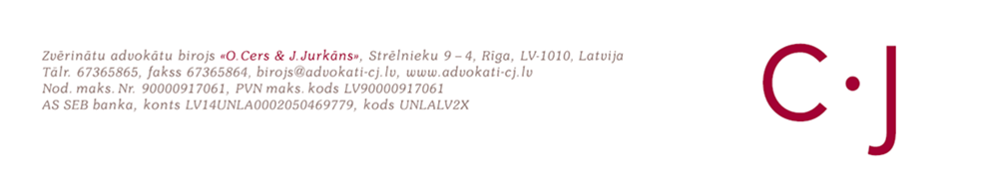

A Study

“Access to Justice in Latvia”

Summary

June 26, 2020

Developed by order of the Ministry of Justice of the Republic of Latvia
Procurement identification No.TM 2020/04/TP

Riga
2020

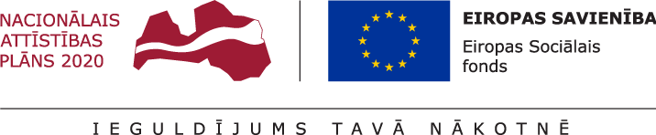

Summary

The study “Access to Justice in Latvia” has been developed to analyze the opportunities of persons at risk of poverty and social exclusion (hereinafter - the target group of the study) to defend their rights and ensure the observance of these rights by resolving legal issues.

The study concludes that currently established criteria and the established system of state-funded legal aid are able to guarantee access to justice of the target group only partially. It can be stated that certain persons and even groups of persons who correspond to the target group of the study do not qualify for the current state-provided legal aid because there are formal obstacles to obtaining the required status or the income level exceeds the income level of the poor or low-income person as determined separately by each municipality. The level of income for obtaining the status of a low-income person differs significantly in different municipalities, which results in a different treatment of persons in comparable situations.

At present in Latvia the level of income that is objectively necessary to meet the basic needs of a person or household is not determined at the national level. Expenses for legal aid are not included in basic needs, and the payment of these expenses from person's own resources is possible only if the person's income is sufficient to satisfy basic needs. Therefore, in order to objectively determine the level of income, to which the state is obliged to provide state-funded legal aid, it is necessary to have a nationally calculated minimum income level for the provision of basic needs for a person, household, region. Without such a general calculation, it is possible to use other benchmarks, such as the national minimum or average wage, but they will not be fully objective because they are not linked to a real basket of goods and services that can be purchased with these funds.

The target group of the study already has various opportunities to receive assistance in resolving legal issues. Assistance is provided both by municipal social services and various non-governmental organizations, in the form of annual days of notaries, lawyers and bailiffs, is available at university Law faculties, and legal aid providers often provide assistance and advice free of charge. However, this assistance is not systematic and is not guaranteed for the whole target group. In addition, it is impossible to count on it. State-funded legal aid, as well as state-paid mediation services in family disputes, is currently systematically available, but this is not enough to ensure full access to justice for the target group of the study.

Surveys and in-depth interviews conducted within the framework of the study show that the target group quite often encounters the need to address legal issues, although in many cases the services of a lawyer or mediator cannot be afforded financially. As a result, a significant number of legal issues are not addressed at all or they are addressed in an inappropriate way, which may reduce the level of protection of the target group's rights and access to justice.

Within the framework of the research, it is proposed to distinguish from the existing state-funded legal aid system the possibility to receive primary state-funded legal aid in the form of one lawyer's consultation by telephone, electronically or in person. If necessary, within the framework of this consultation, it is also possible to prepare separate legal documents or if the Ministry of Justice so decides to receive another consultation if a person has encountered several legal problems.
The study assesses the need to determine a particular income level or property status, which would provide a basis for receiving legal aid paid for by the state. The target group of the study is persons at risk of poverty and social exclusion, which is not defined as a concept, but practically covers a very wide range of persons; therefore the target group for the needs of the study was narrowed to persons whose income does not exceed 320 EUR per month per person living in the household. Determining the income level is an important aspect of ensuring the compliance of the research with the technical specification, therefore the study analyzes several options for determining the income level of individuals. The study also proposes to replace the assessment of personal income with a personal declaration of financial status. Care must be taken to ensure that this declaration is simple enough not to create an additional administrative barrier to obtaining legal aid paid for by the state.

The level of income is an important practical aspect for individuals to be able to afford to pay for a lawyer from their own resources. Within the framework of the study, several options for assessing the level of a person's income have been considered. However, in the opinion of the researchers, a separate income assessment system for receiving primary state-paid legal aid is not useful, as the costs of maintaining the income assessment system (including the costs of appeal) per person will be equal to the costs of providing primary state-paid legal aid. Comparing the development of an income assessment system as one option with the provision of primary legal aid paid for by the state to all persons as a second option, the researchers consider the second option to be more person-friendly and in line with the principle of respect for individual rights. Therefore, also in the light of global experience, it is advised to provide primary state-funded legal aid to all persons upon their request, regardless of income level.

A person can apply for primary legal aid paid for by the state himself or herself or a person can be sent to receive primary legal aid by a social service employee, a state probation service employee, a court employee, a state or municipal police official. Any person or public administration employee may propose a person to apply for a consultation.

Within the framework of primary state-paid legal aid, it will be possible to identify legal issues of persons before they become problematic, to find out their degree of complexity, possible solutions or further actions, giving persons either recommendations for further steps regarding their issue, or information on the possibility to receive secondary state-paid legal aid. The introduction of such a system would make it possible to identify problems of a legal nature more timely, thus reducing the number of cases where persons apply for legal aid late and assistance is no longer possible or is significantly hampered by delays or failure to pay attention to consignments addressed to them. This would, in some cases, eliminate the need for secondary state-paid legal aid.

Secondary legal aid paid by the state includes the current system of state-paid legal aid. The possibility of expanding the range of recipients of secondary legal aid provided by the state is also being considered. Here, too, the minimum income level necessary to meet persons’ basic needs could be used, if one was set. However, until then it is possible to use the national minimum or average wage as a benchmark, taking into account the number of persons living in the household and dependents, similarly as is currently the case with co-payment for state-provided legal aid in cassation. Also any other level of income can be used as a benchmark for granting secondary state-funded legal aid, which is an issue to be decided politically and also depends on the available budgetary resources. In the surveys conducted within the framework of the study, judges, legal aid providers, municipal employees and also representatives of the target group indicated that the appropriate income level for granting secondary legal aid paid by the state ranges from 700 to 1000 EUR per month, applying an additional coefficient for each dependent.

The study analyzes the possibility of determining a partial co-payment for the received legal aid, evaluating its possible benefits and risks. The study establishes that a fully fair system requires a differentiated co-payment depending on the financial situation of the person and the amount of legal aid to be received. However, the establishment of such a system in Latvia for only one purpose - to receive state-paid legal aid - may not be rational. In Scandinavian countries, where such a system is popular, the assessment of a persons' financial situation is also widely used in the provision of other state and municipal services and in decision-making. At the same time, it must be acknowledged that the idea of co-payment for both legal and mediation services would increase the motivation of individuals to use these services responsibly and effectively.

The study analyzes the availability of mediation services in Latvia, finding that there are currently several problems. The knowledge of the public about mediation and its possibilities is poor, as well as about the advantages of mediation over litigation. Cooperation between certified mediators and judges needs to be improved, as well as joint development of good practice guidelines. Also, in order to promote mediation, various state and local government institutions should be involved (a cooperation and support network should be established), with the Council of Certified Mediators undertaking the co-ordination of co-operation.

For the socially and economically vulnerable persons, the financial aspect is a real barrier to accessing mediation. Mediation as a form of dispute resolution in Latvia must be included in the existing system of state-funded legal aid.

The emotional readiness of persons to participate in mediation is also important for the initiation and successful process of mediation. The readiness of Latvian population to participate in the mediation process currently is quite low. A long-term solution is to integrate mediation into school curricula. Only a few need to know the court process, but everyone must understand mediation and be able to use it in any kind of dispute.

The study analyzes the risks and benefits of introducing mandatory mediation and proposes to establish mandatory initial consultation with a mediator in certain categories of cases before going to court (compulsory mediation). Initially, such a procedure could be established in family disputes, but it is also possible to extend it to labor disputes and inheritance cases. Also, in the course of the research, it has been established that a methodology should be developed and a procedure should be established for the regular and accurate listing and publication of statistics on mediation cases and their results.

The study also offers other proposals for further development of the mediation service in Latvia.

